**Lab 3 Group 12 Session 205 Report**

**Part 1**: LogicalStep_Lab3_top.vhd File

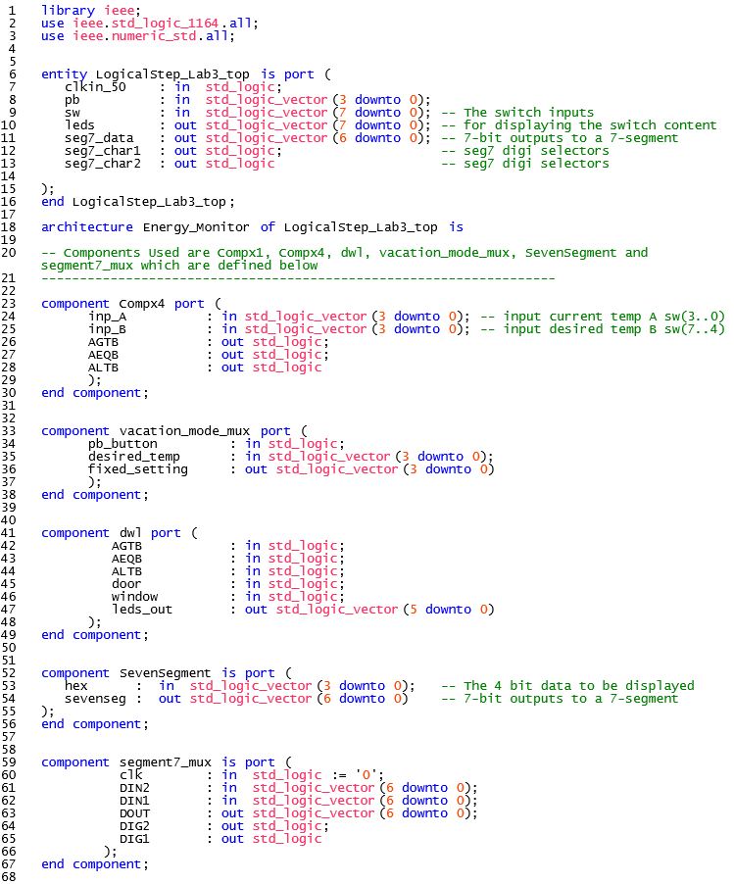

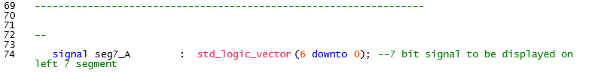

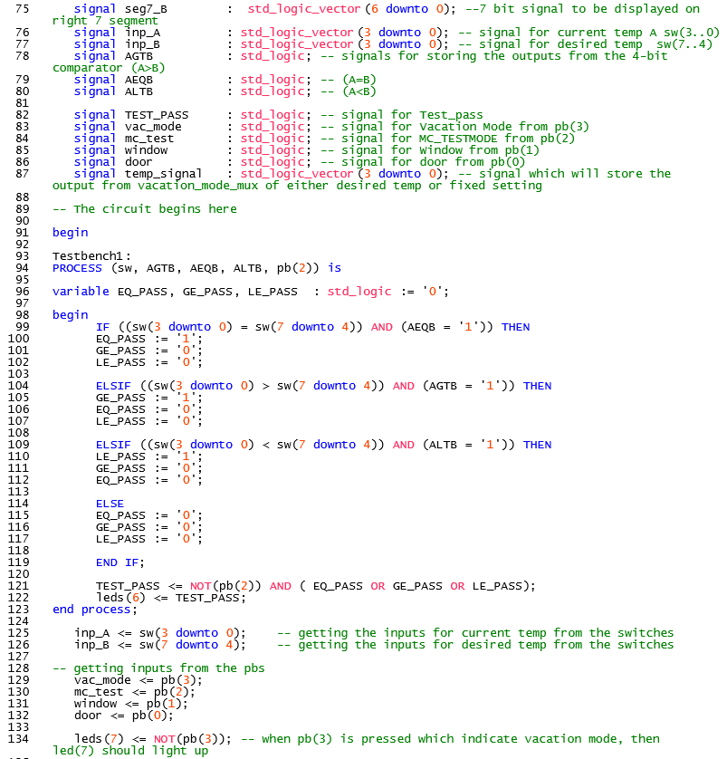

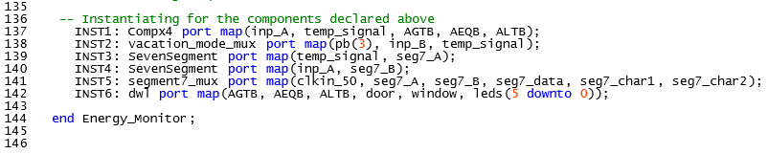

**Part 2**: Subordinate VHDL Files

1. Compx1.vhd File

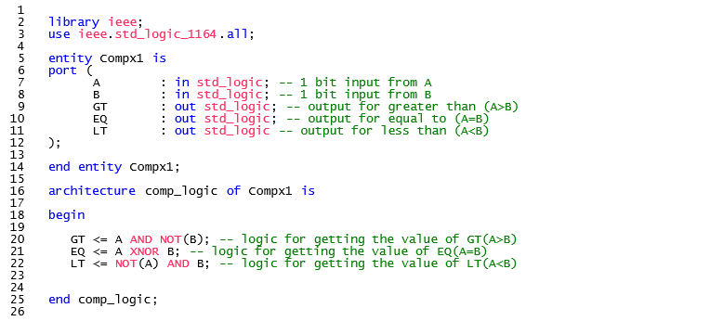

1. Compx4.vhd File

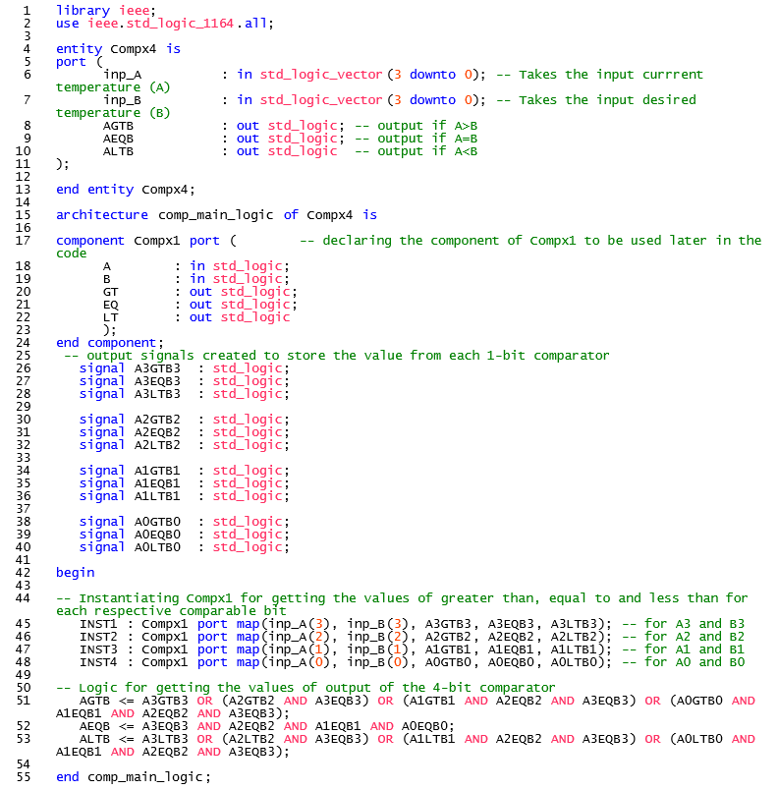

1. vacation_mode_mux.vhd File

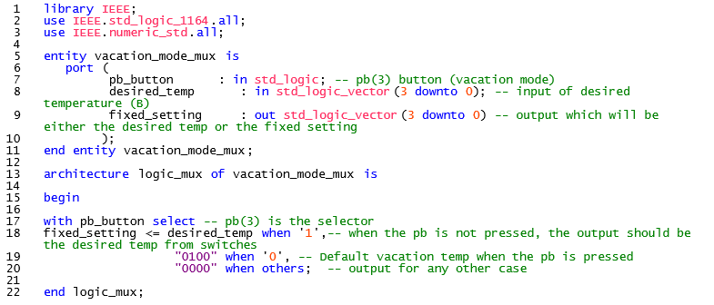

1. dwl.vhd File

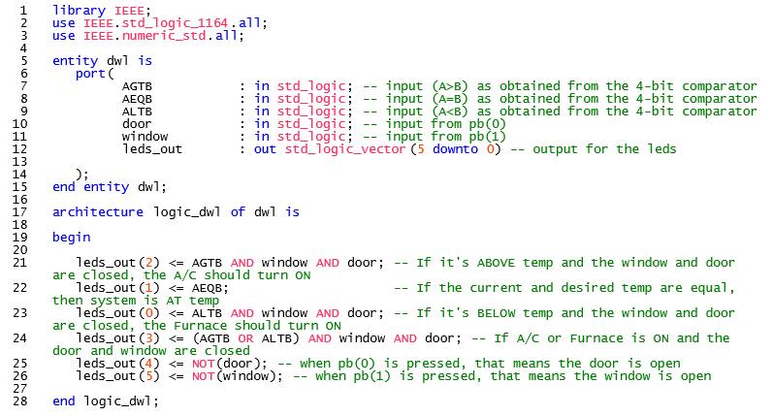

**Part 3:** Supporting Documentation

1. Truth Table

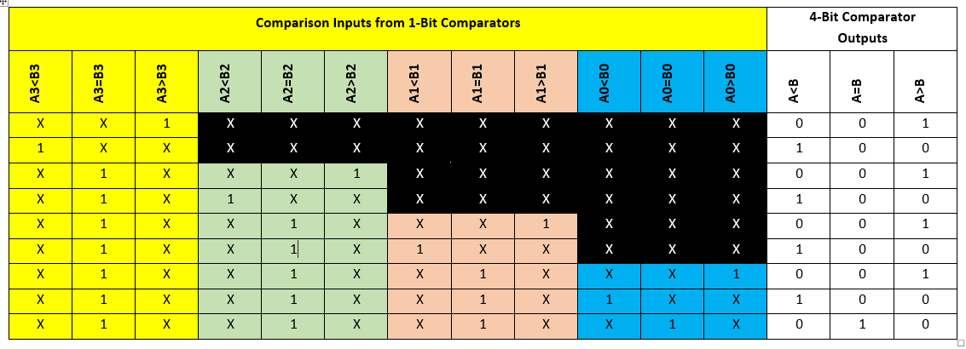

1. Simulations of Comparator

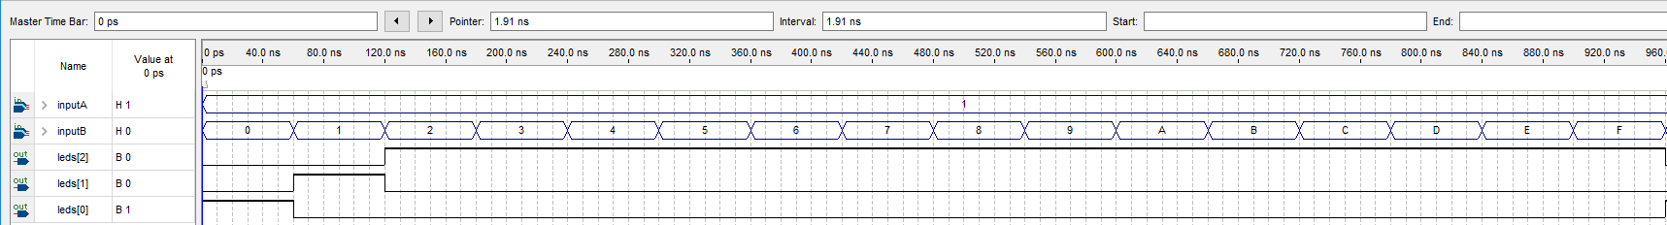

**Figure 1: Simulation 1 with Input_A set to hex 1**

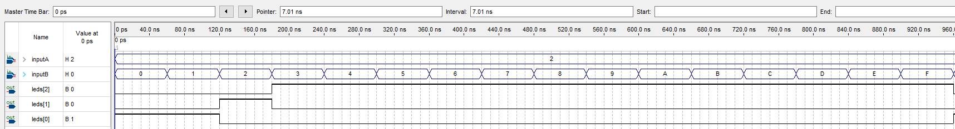

**Figure 2: Simulation 2 with Input_A set to hex 2**

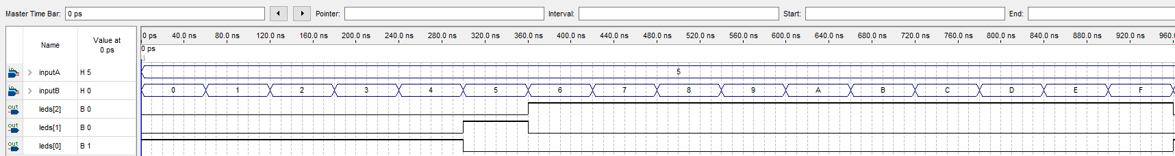

**Figure 3: Simulation 3 with Input_A set to hex 5**

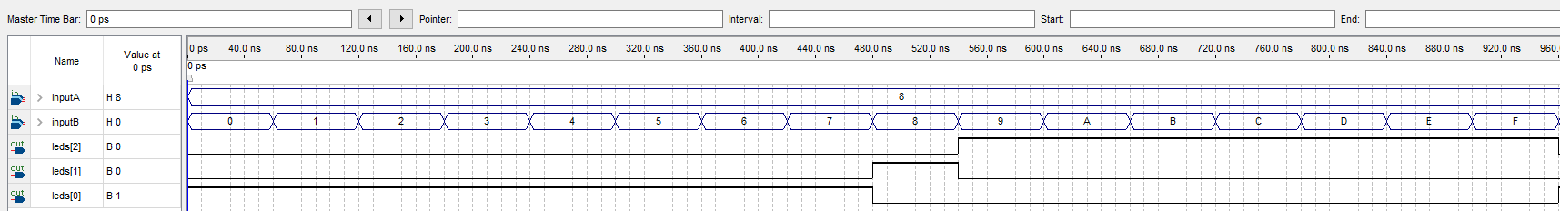

**Figure 4: Simulation 4 with Input_A set to hex 8**

1. RTL View of the Logic Design (Top Level)

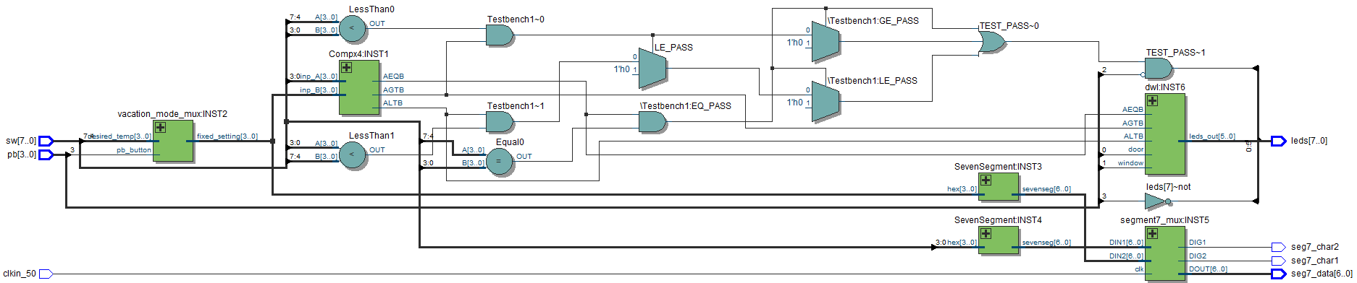

**Figure 5: RTL View**

1. Total Design Logic Elements Used: **59**

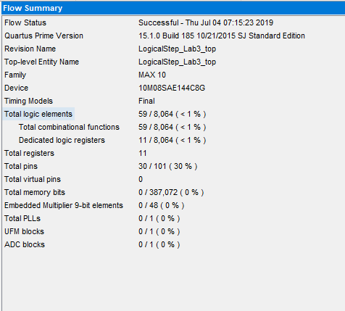

**Figure 6: Flow Summary**